
Journal of Naval Science and Engineering
2010, Vol. 6 , No.2, pp. 51-75
NATURE OF CORPORATE SOCIAL
RESPONSIBILITY FROM THE POINT OF
MARKETING MANAGEMENT VIEW AND
APPLICATION OF CONTENT ANALYSIS ON
SOCIAL RESPONSIBILITY PROJECTS
Serdar PİRTİNİ, Ph. D.
Associate Professor of Marketing
Marmara University
Department of Business Administration
serdarpirtini@marmara.edu.tr
Şakir ERDEM, Ph. D.
Assistant Professor of Marketing
Marmara University
Department of Business Administration
serdem@marmara.edu.tr
Abstract
Corporate Social Responsibility is considered a global new trend in today’s
business world. This trend is recent and organizations have been struggling
to understand their social responsibility roles, as it’s not an easy task
because of the immediate expectations of the changing market. Furthermore,
social responsibility projects have gained a concensus because both
organizations and non-profit organizations think that these projects need to
be implemented to create a strong brand communication of corporates.
That’s why; many companies start to give importance to these projects. This
paper aims to analyse the content of the official web sites of several
national and global firms, by first stating the names of their projects and
looking at their aims, and then defining the results they have achieved.
51
Nature Of Corporate Social Responsibility From The Point Of Marketing
Management View And Application Of Content Analysis On Social
Responsibility Projects
PAZARLAMA YÖNETİMİ AÇISINDAN
KURUMSAL SOSYAL SORUMLULUK VE
SOSYAL SORUMLULUK PROJELERİ
ÜZERİNE BİR UYGULAMA
Özetçe
Günümüzün iş dünyasında, kurumsal sosyal sorumluluk yeni bir yükselen
global trend olarak dikkate alınmaktadır. Özellikle son yıllarda kurumlar,
değişen pazar dinamikleri ve müşteri beklentileri çerçevesinde toplumsal
anlamda sosyal sorumluluk rollerini anlamaya ve bunu en doğru şeklilde
konumlandırmaya çalışmaktadırlar. Öyle ki; kâr amaçlı organizasyonlar ve
kâr amacı gütmeyen örgütlerin tamamında, kamuoyunda güçlü bir marka
iletişimi oluşturabilme yönünde kurumsal sosyal sorumluluk projejleri
adına güçlü bir uzlaşma olduğu görülmektedir. Bu gelişmelerin bir
yansıması olarak da bir çok kuruluş, sosyal sorumluluk kampanyaları
yapmayı öncelikli gündem maddelerinin başına almaktadırlar. Bu
çalışmada, örnek olarak seçilen farklı sektörlerden yerli ve global ölçekteki
firmaların kurumsal sosyal sorumluluk projelerine ilişkin proje isimleri,
amaçları, içerikleri ve pazarlama yönetimi açısından kazandırdıkları
üzerine kalitatif bir araştırma tekniği olarak içerik analizi uygulanmış ve
yorumlanmıştır.
Keywords: Corporate Social Responsibility, Marketing Managemet,
Content Analysis.
Anahtar Kelimeler: Kurumsal Sosyal Sorumluluk, Pazarlama Yönetimi,
İçerik Analizi.
1.
INTRODUCTION
Social responsibility is the obligation for an organization, which
requires ethical, accountable, and reactive duty towards the needs of society.
This definition suggests that socially responsible firms should undertake two
things: (1) eliminating negatives and (2) doing positives. In general,
business experts agree that socially responsible firms are more likely to
thrive and survive in the long-term. Companies engaged in positive
52
Serdar PİRTİNİ & Şakir ERDEM
activities generate quality publicity and customer loyalty. Firms, on the
other hand, that work strongly toward reductions in unfair practices,
pollution, harassment, and other negative activities are more likely to stay
out of court, and they suffer fewer negative word-of-mouth comments by
consumers who are not fully satisfied [1].
It must be emphasized that matters of ethics and social responsibility
permeate every aspect of the marketing management process. Indeed, most
marketing decisions involve some degree of moral judgment and reflect an
organization’s orientation toward the publics with which it interacts.
Enlightened marketing executives no longer subscribe to the view that if an
action is legal, then it is also ethical and socially responsible. These
executives should be sensitive to the fact that the marketplace is populated
by individuals and groups with diverse value systems. Moreover, they
should recognize that their actions will be judged publicly by others with
different values and interests [2].
2.SCOPE OF
MARKETING CONCEPT
SOCIAL
RESPONSIBILITY
AS
A
In today’s world of business, the wants and needs of society are an
important contextual consideration. Firms must not only produce excellent
goods and services and produce a healthy profit, but also be concerned with
their relationship with society at large as well as with the environment. The
marketing concept has evolved into market orientation, and firms are more
heavily focused on wants and needs of consumers, but this is no longer
sufficient. There is a broader context in which the firm operates, and the
well-being of society and consumers must be taken into consideration. Not
only do consumers expect that corporations will operate legally and fairly,
they also want them to act ethically, help charitable causes, clean up the
environment, and improve conditions for citizens locally, regionally,
nationally, and in some cases internationally. Companies should now be
socially responsible [3].
53
Nature Of Corporate Social Responsibility From The Point Of Marketing
Management View And Application Of Content Analysis On Social
Responsibility Projects
In the last few years the interest in the concept of corporate social
responsibility has grown and received increasing attention, with leading
companies developing sophisticated approaches. At the same time
marketing techniques have been refined and new concepts developed whilst
corporate community investment and cause related marketing have also
developed. Cause-related marketing demonstrates and indeed enhances
corporate values and reputation and much more besides, and this is
increasingly being appreciated by the board, the chief executive, corporate
affairs, marketing and fundraising departments. In the marketing and
fundraising world there has been a quest for new and more effective ways of
engaging the various target audiences or stakeholders. Consumers are
increasingly sophisticated and cynical and have growing expectations of
business. They expect compliance, honesty and ethical trading atmosphere
[4].
Finally, both organisational and individual, but also environmental
premises strongly determine a firm’s degree of corporate social
responsibility engagement. In this sense, research about important
determinants including individual decision-maker factors like CEO values,
manager personality and other personal attributes like his or her degree of
religiousness, minority background and ethical consciousness, but also
institutional influences like organisational form, firm newness, resource
availability, firm size, ethical climate, corporate culture, as well as the
conditions of the external environment like its dynamism and munificence,
industry attributes and governmental programs are consecutively worked off
to enhance the understanding of their respective impact upon corporate
social responsibility programs’ development and implementation [5].
Business for social responsibility, founded in 1992, is a membership
organization made up of companies seeking to sustain their commercial
success in ways that demonstrate respect for ethical values, people,
communities, and the environment. Through the policies and practices of
socially responsible business, companies create value for investors,
customers, employees, local communities, and other stakeholders. Business
for social responsibility regards corporate social responsibility as business
54
Serdar PİRTİNİ & Şakir ERDEM
decision making linked to ethical values, compliance with legal
requirements, and respect for people, communities, and the environment. In
this respect, corporate social responsibility is a large umbrella under which a
company must view its overall positioning and determine how its business
activities affect employees, the environment, communities, consumers,
investors, and other stakeholders—and most importantly in what order of
priority [6].
Decisions on ethics and corporate social responsibility are at the
heart of corporate strategy. They particularly influence the purpose of the
organization in terms of the standards and conduct that an organisation sets
itself in its dealings within the organisation and outside its environment.
Corporate social responsibility has a wider remit to include the
organisation’s responsibility beyond the minimum to its employees and
those outside the organisation. Topics will vary with each organisation but
may include environmental ‘green’ issues, treatment of employees and
suppliers, charitable work and other matters related to the local or national
community [7].
Increasingly, the responsibility that an organization demonstrates
towards the diverse communities within which it works is important in
shaping the attitudes of those with whom it relates. In turn, this helps to
develop and project the reputation. A key element in corporate social
responsibility can be community support, charitable involvement and the
sponsorship of good causes [8].
National companies give more importance and allocate more budget
to cause-related marketing campaigns with a social responsibility approach
in the process of joining European Union. International brands should
observe the real social needs of local market while defining the subject of
cause-related marketing campaign so that they would be able to build up a
strong brand communication. Cause-related marketing campaigns influence
to increase the awareness and loyalty of the brands and this gives the brands
a competition power within the others. Both national and international
brands in Turkish market try to win the Turkish consumers’ sympathy with
55
Nature Of Corporate Social Responsibility From The Point Of Marketing
Management View And Application Of Content Analysis On Social
Responsibility Projects
having social campaigns. This actually shows that cause-related marketing
campaign is one of the strong tools in marketing for supporting company
reputation and brand image in Turkey [9].
3.APPLICATION OF CONTENT
SOCIAL RESPONSIBILITY PROJECTS
3.1.
Methodology
ANALYSIS
ON
The aim of this study is to examine the social responsibility projects
of the firms both in a national and in a global perspective. To achieve this
aim the content of the official web sites of several national and global firms
was analysed.
Content analysis was chosen as the research technique of this study
because it is a research technique for making replicable and valid inferences
from texts (or other meaningful matter) to the contexts of their use [10].
These inferences are about the message itself and the sender(s) or the
audience of the message. The rules of this inferential process vary with the
theoretical and substantive interests of the investigator [11]. As a research
tecnique it provides new insights, increases the understanding of the
researcher about particular phenomena, or informs of practical actions [10].
All these reasons facilitate the use of content analysis and also point out the
fact that no other research technique would be appropriate for achieving the
aim of this study.
In this study the social responsibilty projects of both Turkish and
global firms were examined. To select the Turkish firms, social
responsibilty projects were categorized as projects related to;
1)
2)
3)
4)
5)
Education,
Health,
Environment,
Culture / Arts,
Sports,
56
Serdar PİRTİNİ & Şakir ERDEM
6) History,
7) Community
Then, firms that deal with social responsibility projects related with
each of these seven categories are found and the well-known ones were
chosen to be examined in more detail. Besides, the social responsibilty
projects of foreign firms that only produce dairy products are included in the
study. The study is conducted between November 2009 and January 2010.
3.2.
Social Responsiblity in Turkey
In Turkey corporate social responsibility projects are executed in
seven different areas. As mentioned before these areas are; education, health,
environment, culture/arts, sports, history and social matters. Turkcell,
Colgate, Cheetos, Pınar and Danone are the firms that execute education
related social responsibility projects. Tetra Pak, Aygaz, Pfizer, Roche and
Eczacibasi are the examples of firms dealing with health related social
responsibility. YKM, Coca Cola, Philips, Nokia and HP are some of the
important firms that are popular with their environmental social
responsibility activities. Koç Holding, Efes, Eti, Pınar and Banvit are the
examples of firms spending great effort on social responsibility projects
related to culture/arts. Vestel, Danone, P&G, Omo and Turkcell are the
examples of firms dealing with sports related social responsiblity activities.
Opet, Efes, Aygaz, Çalık Holding and KoçBank are some of the examples
of the firms dealing with social responsibility projects concerning history.
Finally, for the firms executing community related social responsibility
projects Sabancı Holding, Hurriyet, Koç Holding, Unilever and Beta can be
considered as good examples.
To understand the public’s opinion about social responsibility
activities of firms and people, a research was conducted by a monthly
magazine named Capital. According to this survey; for Turkish people the
most socially responsible firm is “Sabancı Holding” and the most socially
responsible person is “Güler Sabancı”. Also in the survey “Hayrettin
Karaca” is chosen as the most socially responsible Turkish leader.
57
Nature Of Corporate Social Responsibility From The Point Of Marketing
Management View And Application Of Content Analysis On Social
Responsibility Projects
According to another survey conducted in 2008 by United Nations,
the problems and risks associated with Turkey’s social responsibility
projects are revealed. The most important points of this report can be
summarized as follows;
1)In Turkish Business Environment there is still no concensus
about the scope and the definion of corporate social responsibility, and this
directly affects social responsibility practices of the firms.
2)Most of the social responsibility projects and activities are
executed by non-governmental organizations and sponspors in Turkey.
3)There is need for social responsibility projects related to
human and employee rights.
4)Turkish firms mostly perceive social responsibility projects
as tools for increasing marketing and corporate reputation.
5)Multinational companies affect the social responsbility
activities positively in Turkey.
3.3 Selected Best Social Responsibility Practices of
Turkish Firms
Examples of social responsibility projects in the health area: In the
area of health related social responsibility, Eczacibasi, Aygaz and Tetra
Pak’s projects are examined. nokta
“Eczacibasi” with its project called “Hygiene” organized free
seminars and panels for 5.5 millions of elemantary students to inform them
about hygiene and hygiene related issues (See Figure 1). The company also
renovated the toilets of some primary schools with its “Vitra and Artema”
branded products. Eczacibasi won two very important awards with this
social responsibility project in the USA [12].
58
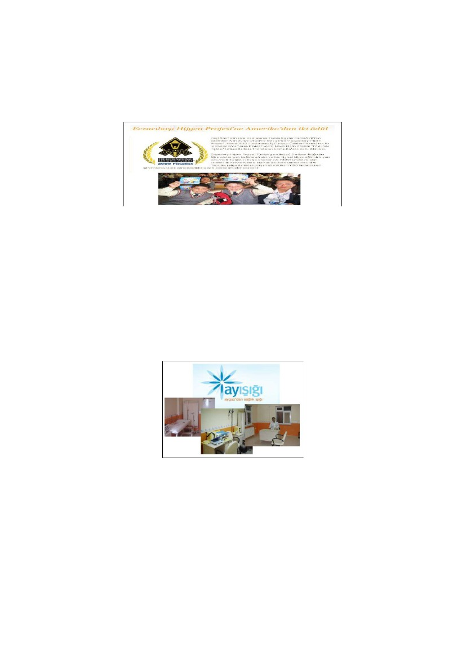

Serdar PİRTİNİ & Şakir ERDEM
Figure 1. Eczacibasi: The Hygiene Project
Source: http://www.eczacibasi.com.tr/articles/detail/detail2.asp?id=962&archive=1
Another social responsibility project in the field of health was
executed by AYGAZ. For the company’s 45th foudation day celebrations a
project called “Ayışığı: Aygaz’dan Sağlık Işığı” was carried out (See Figure
2). In 45 different cities, Aygaz renovated 45 health centers’ vaccine rooms
[13]. Besides, Tetra Pak held a social responsibility project called “Sağlık
İçin Sağlıklı Süt İçin”, which was supported by the Ministry of Health.
Within the meaning of this project Tetra Pak organized free seminars to
inform nurses about how to avoid nutritional deficiency (See Figure 3).
1706 nurses were informed about the benefits of milk consumption and the
features of healthy milk [14].
Figure 2. AYGAZ’s Social Responsibility Project
Source: http://www.aygazayisigi.org, 2009
59
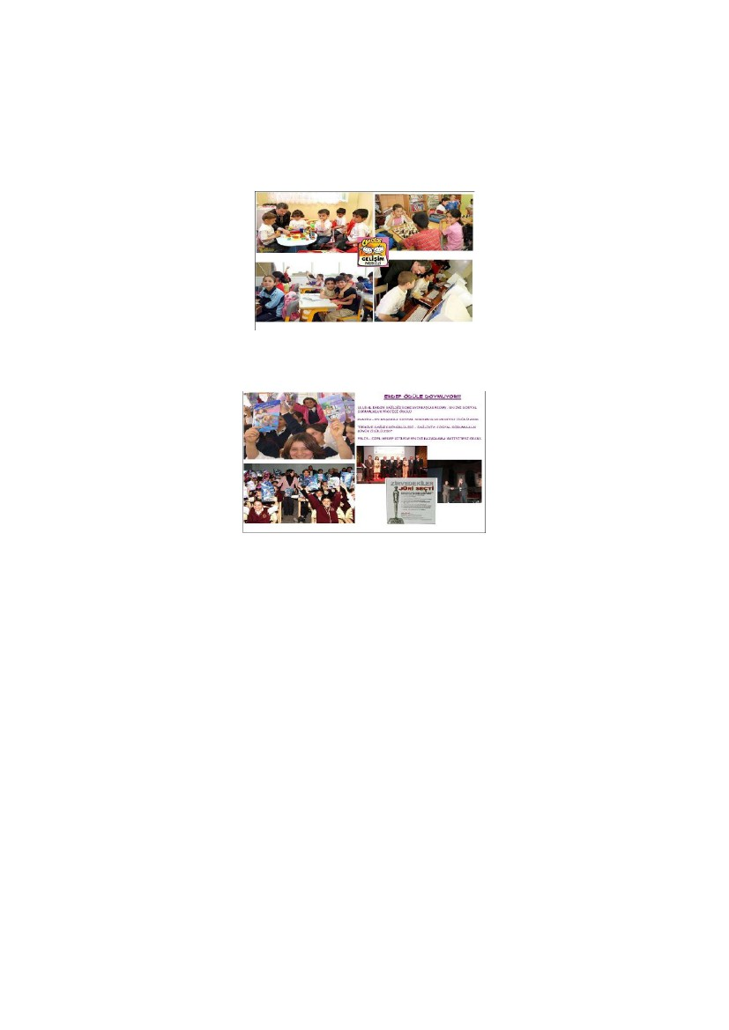
Nature Of Corporate Social Responsibility From The Point Of Marketing
Management View And Application Of Content Analysis On Social
Responsibility Projects
Figure 3. Tetra Pak’s Social Responsibility Project
Source: http://www.tetrapak.com/tr/about_tetra_pak
Examples of social responsibility projects in the education area: In
the field of education related social responsibility, Cheetos, P&G, Turkcell,
Colgate and Danone’s projects are examined. nokta
With Cheetos’ social responsibility project called as“Gelişim
Merkezleri Projesi” eight development centers for children between the ages
of 4-14 ages were founded in the eastern cities of Turkey. The aim of these
centers was to promote and support children to develop themselves mainly
in sports, culture, education and arts (See Figure 4). By the year 2009,
10.000 children had benefited from these centers [15].
Another social responsibility project in education area was executed
by P&G. With the project called “Ergenlik Dönemi Değişim Programı”, for
15 years P&G had given free seminars to nine million students and 500.000
mothers about adolescence. Also by the use of hotlines several questions of
the students were answered (See Figure 5). P&G won several awards in
return of these social responsibility practices [16].
60
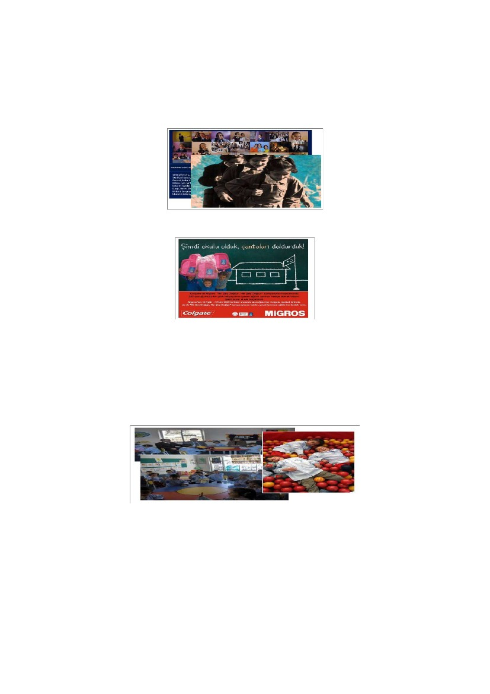
Serdar PİRTİNİ & Şakir ERDEM
Figure 4. Cheetos’ Social Responsibility Project
Source: http://www.cheetosgelisimmerkezi.com/, 2009
Figure 5. P&G’s Social Responsibility Project
.Source: http://www.pg.com.tr/procter/, 2010
Turkcell’s social responsibility project related to education is called
“Kardelenler” (See Figure 6). This project aims to provide financial and
moral support for young girls who are not able to go on their education or
even haven’t started their educations in rural areas [17]. Another company
interested in educational social responsibility projects is Colgate. The firm
gives customers the chance to support children’s education by buying
Colgate branded products in Migros (See Figure 7). The name of the project
was “Bir Şey Değişir, Her şey Değişir” and its execution was supported by
TOÇEV [18].
61
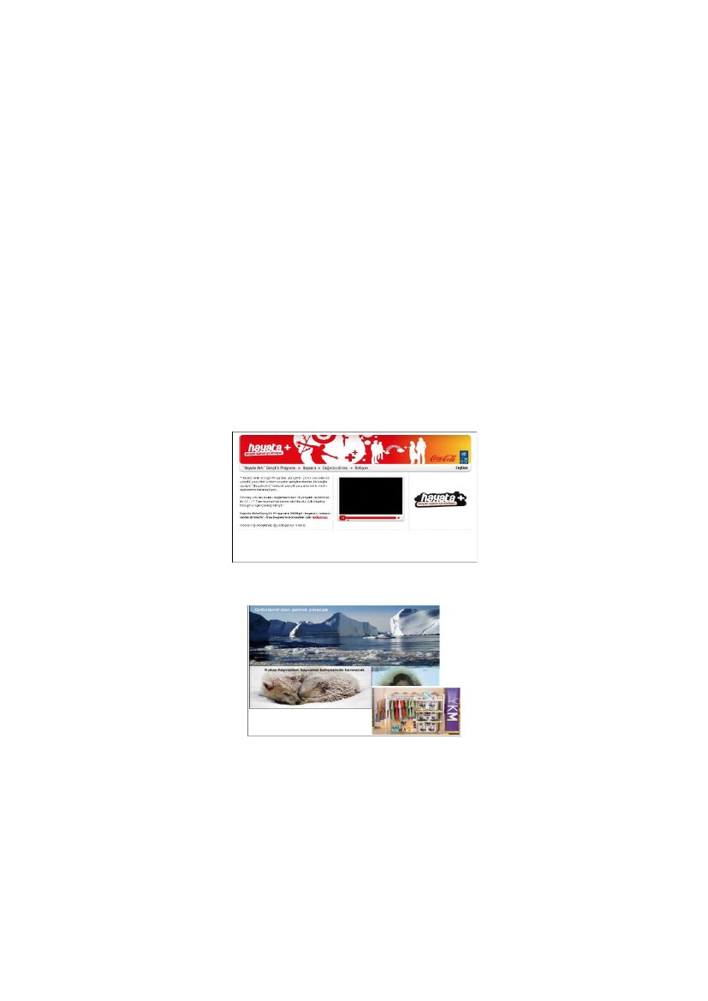
Nature Of Corporate Social Responsibility From The Point Of Marketing
Management View And Application Of Content Analysis On Social
Responsibility Projects
Figure 6. Turkcell’s Kardelenler Project
Source: kardelenler.turkcell.com.tr, 2010.
.
Figure 7. Colgate’s Social Responsibility Project
Source: http://ortakalan.com.tr/haber.asp?S=292&HID=1379, 2009
Danone has carried out a project named as “Gülümseyen Gelecek
Ana Sınıfları” with the support of “Ministry of Education” and “Çağdaş
Yaşamı Destekleme Derneği” (See Figure 8). Within the context of this
social responsibility practice, 250 nursery schools have been founded in
different locations of Turkey [19].
Figure 8. Danone’s Social Responsibility Practice
Source: www.gulumseyengelecek.com/, 2010.
62
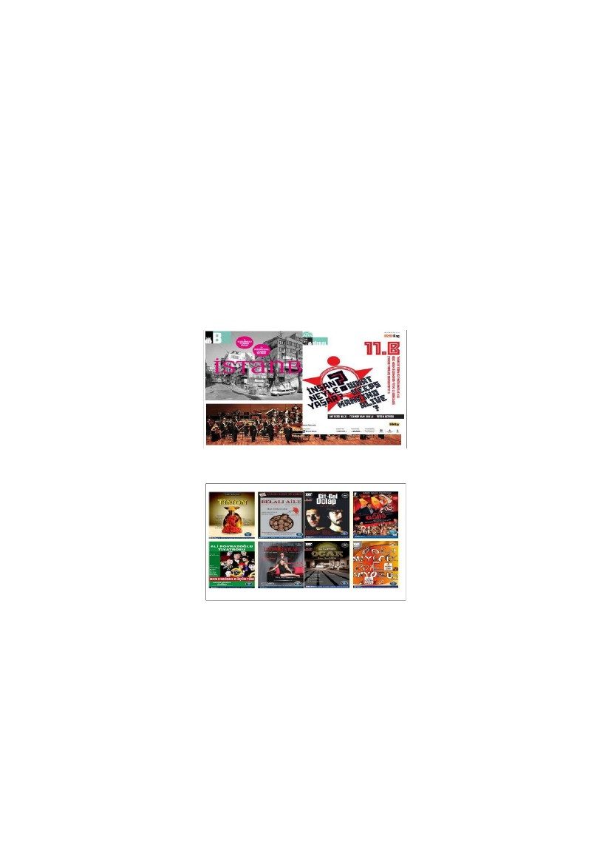
Serdar PİRTİNİ & Şakir ERDEM
Examples of social responsibility projects in the environment area:
Coca Cola and YKM’s social responsibility projects will be examined in
this field.
Coca Cola Turkey has organised a contest for young people who
are between 16-26 years old (See figure 9). They design environment
related projects for the contest and the ones that get high points from the
jury are financially supported by Coca Cola, Turkey [20]. YKM carries out
a social responsibility project with WWF (World Wide Fund for Nature) for
the sake of environment. The firm produces products with panda logos and
displays them for sale at specific stands in some of its stores (See Figure 10).
The aim of this project is to increase public sensitivity for nature and to
attract their attention to global warming. The income from the sale of these
products is directly donated to WWF [21].
Figure 9. Coca Cola Turkey’s Project
Source: www.hayataarti.org/, 2010.
Figure 10. YKM’s Social Responsibility Project
Source: www.kurumsalhaberler.com/2010.
63
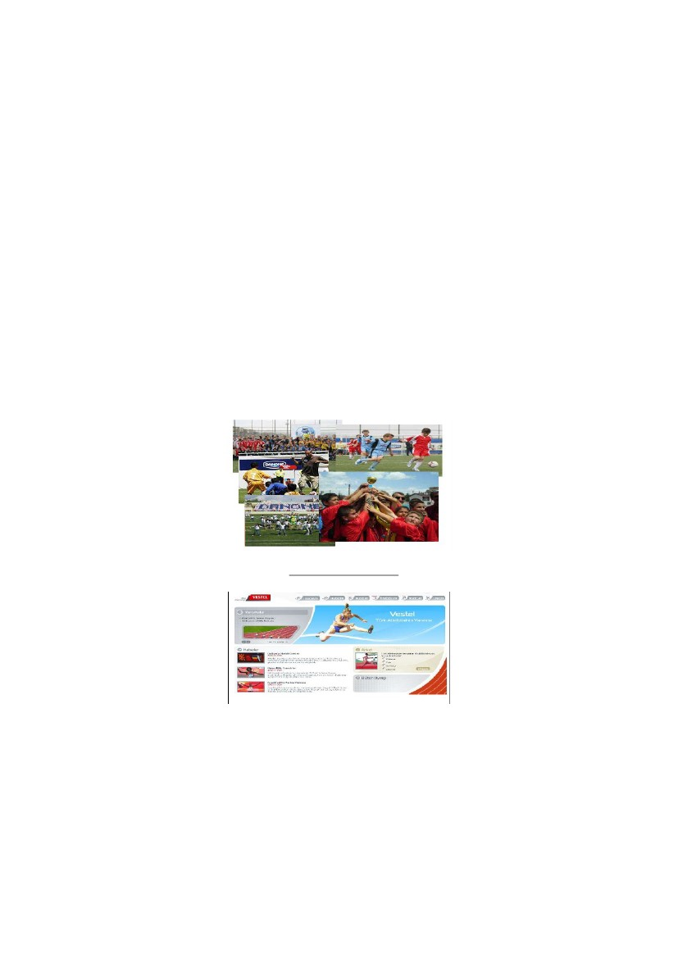
Nature Of Corporate Social Responsibility From The Point Of Marketing
Management View And Application Of Content Analysis On Social
Responsibility Projects
Examples of social responsibility projects in the culture/arts area:
In the field of culture/arts related social responsibility, Koç Holding and
Efes’ practices are examined below.
One of the areas that Koç Holding carries out social responsibility
projects is culture/arts (See Figure 11). Within the context of one of these
projects Koç Holding undertakes the sponsorship of the International
İstanbul Biennial [22]. Efes has also chosen the culture/arts area as its main
social responsibility area and it has been supporting the Turkish Theatre for
14 years (See Figure 12). The company has undertaken the sponsorship of
approximately 300 representations [23].
Figure 11. Koç Holding’s Social Resp. Practice
Source: www.koc.com.tr/tr-tr/Basin_Merkezi, 2009
Figure 12. Efes’ Social Responsibility Practices
Source: http://www.efespilsen.com.tr/tiyatro.aspx, 2010.
64

Serdar PİRTİNİ & Şakir ERDEM
Examples of social responsibility projects in the sports area: In this
part, social responsibility projects of Danone and Vestel will be examined in
more detail.
With the support of Ministry of Education, Danone organizes free
football tournaments for seven-year-old boys all around Turkey. Several
schools from 81 different cities of Turkey attend this tournament every year
(See Figure13). With the help of this project many talented young boys have
the chance to flourish [24].
On the other hand Vestel, with its project named “Vestel Turk
Atletizminin Yanında” undertakes some activities to support Athletism in
Turkey (See Figure 14). Since 2004, with its social responsibility practices
Vestel has been aiming to increase the attention and interest of Turkish
youth on Athletism [25].
Figure 13. Danone’s Social Responsibiliity Practices
Source: www.tumgazeteler.com/, 2009
Figure 14. Vestel’s Support For Athletism
Source: http://www.vestel.com/index.aspx, 2009.
65
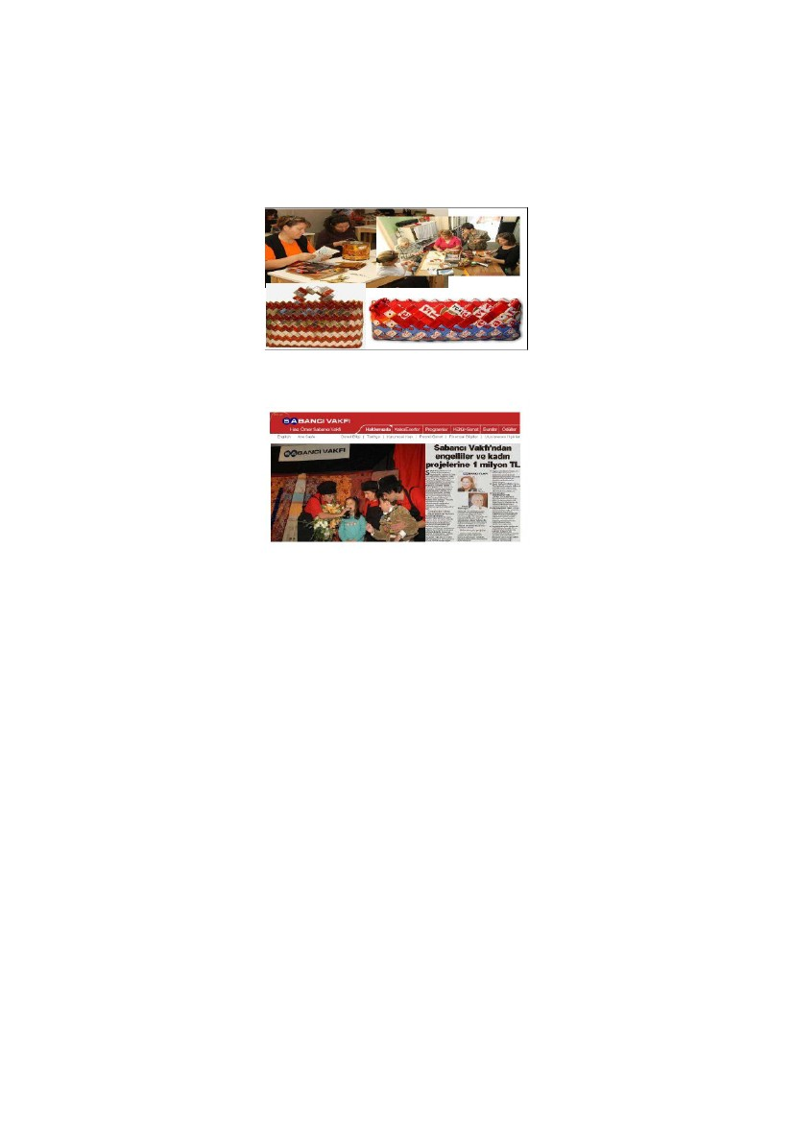
Nature Of Corporate Social Responsibility From The Point Of Marketing
Management View And Application Of Content Analysis On Social
Responsibility Projects
Example of social responsibility projects in the area of history:
Çalık Holding has provided financial support for the restoration of “Yalova
Köşkü” because it is one of the houses in which Ataturk, the founder of
Turkish Republic, lived in Turkey (See Figure 15) [26].
Figure 15. Yalova Köşkü, Before and After Restoration
Source: www.calik.com/sayfa.aspx?id=8, 2010.
Example of social responsibility projects in the area of community:
Unilever, Sabancı Holding, Hurriyet, Koç Holding are the examples of firms
dealing with social responsibility projects in this area.
With its project called “Çöpadam” Unilever have founded several
workshops in Ayvalık, Diyarbakır and Istanbul for unemployed women (See
Figure 16). In these workshops women make bags and accessories, and have
obtained the chance to sell them and make a living [27]. Sabancı Holding
has also allocated a budget to support the sustainable social responsibility
projects about children, women and disabled people (See Figure 17). The
firm donates minimum 100.000 TL and maximum 300.000 TL for each of
the projects [28].
66
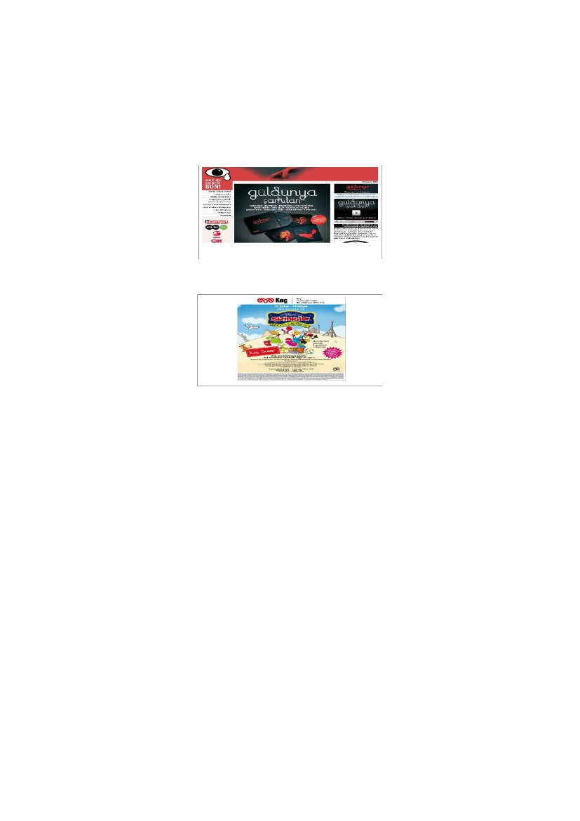
Serdar PİRTİNİ & Şakir ERDEM
Figure 16. Unilever’s Social Responsibility Project
Source: copmadam.sabanciuniv.edu, 2010
Figure 17. Sabancı Holding’s Project
Source:www.sabancivakfi.org/tr/?programlar/hibe, 2010.
In cooperation with several non-governmental organizations and
governorship of İstanbul, Hurriyet aims to reduce the violence in families
and to make people conscious about the issue. Within the context of this
project seminars were organized for families and also a music album was
launched (See Figure 18). The sales revenue of this album is donated to the
project [29].
As part of its 80th foundation day celebrities, in cooperation with
BKM, Koç Holding organized a musical for children. This musical aimed
to facilitate the mental and cultural development of the children (See Figure
19). During the project the musical was shown in 17 different cities of
Turkey and reached about 100.000 children [30].
67
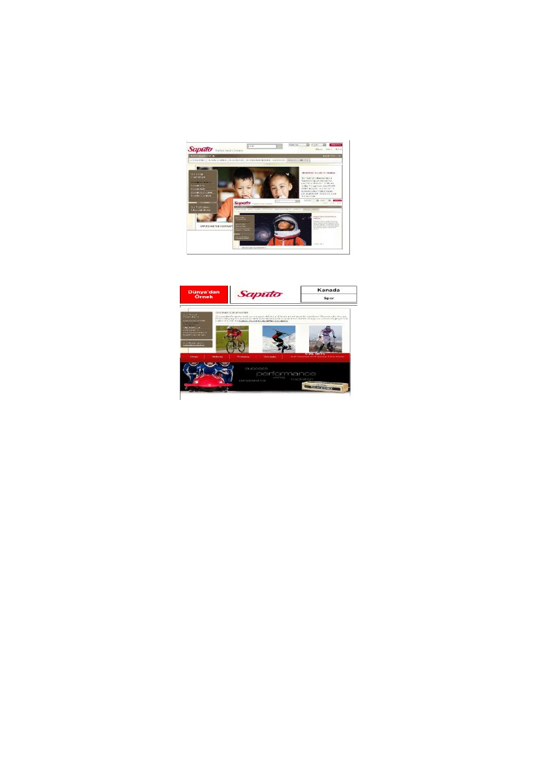
Nature Of Corporate Social Responsibility From The Point Of Marketing
Management View And Application Of Content Analysis On Social
Responsibility Projects
Figure 18. Hurriyet’s Social Responsibility Project
Source: www.hurriyet.com.tr/magazin/anasayfa/10509308asp, 2010
Figure 19. Koç Holding’s Social Responsibility Project
Souce: www.bkmonline.net/tr/organizasyon.bkm,2010.
3.4.
Firms
Selected Best Social Responsibility Practices of Foreign
The Case of Saputo: Among the largest milk processors in the world,
a Canadian company Saputo publishes social responsibility report every
year to inform its investors. The company’s social responsibility practices
can be grouped into four categories: 1) community 2) Sport 3) Quality, and
4) Environment. Saputo also supports social responsibility projects for
children in the USA, Canada and Argentina. For instance, it supports school
nutrition programs, offers art workshops to children with mental disorders,
and grants aids to children suffering from life-threatening diseases (See
Figure 20). The firm is the official sponsor of Vancouver 2010 Winter
Olympics. It also provides scholarship for successful sportsmen (See Figure
21) [31, 32].
68
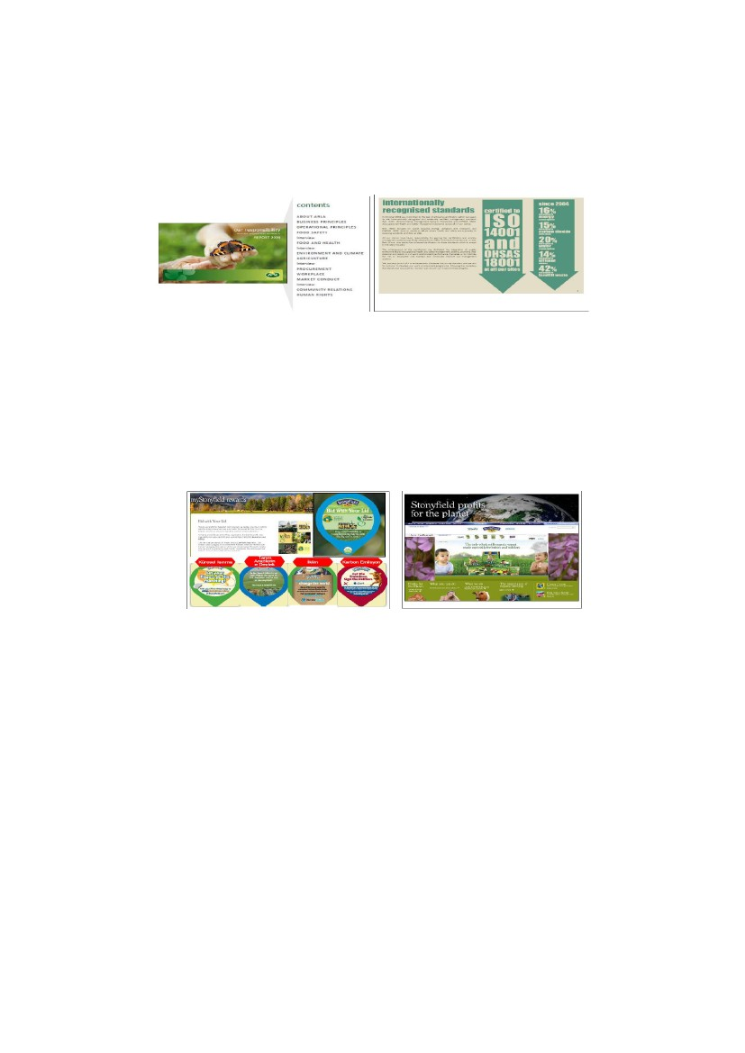
Serdar PİRTİNİ & Şakir ERDEM
Figure 20. Saputa Supporting Children
Source: www.saputo.com/consumers/social/,2010
Figure 21. Saputa Supporting Sportsmen
Source: http://olympics.saputo.com/about.aspx,2010.
The Case of Arla: Arla, a Swedish Company, publishes its social
responsibility reports. The report is displayed on its official web site and
summarizes its social responsibilty practices mainly in the areas of
environment, health, and agriculture on a yearly basis. The company has the
ISO14001 and also the OHSAS18001 certificates on environmental
standards. Arla announces that it obeys the internationally recognised
environmental standarts. In their report published in 2007, they pointed out
that in their production process the amount of waste was significantly
reduced. The following figure shows the examples of Arla’s social
responsibility [33].
69
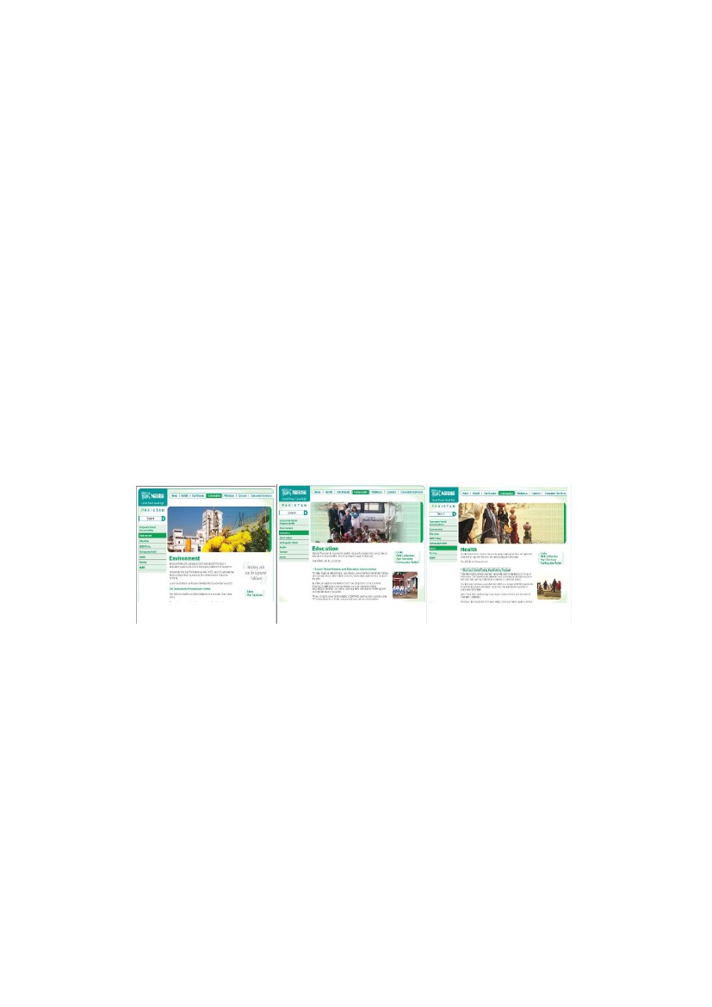
Nature Of Corporate Social Responsibility From The Point Of Marketing
Management View And Application Of Content Analysis On Social
Responsibility Projects
Figure 22. Arla’s Social Responsibility Practices
Source: http://www.arla.com/,2010
The Case of Stonyfield: Stonyfield, an American firm, puts
information about their social responsibility projects and social messages on
its yogurt covers. By this way it informs its customers about social
responsibilty projects and directs them (See Figure 23). Within the context
of its “Profit for Planet” project every year it donates 10% of its profit to
non-profit organizations dealing with environmental projects [34].
Figure 23. Stonyfield’s Social Responsibility Practices
Source: http://www.stonyfield.com/,2010.
The Case of Dairy Crest: The English firm’s social responsibility
report (2009-2010) points out that firm’s social responsibility practices can
be categorized into four groups connected to their aims: workplace (to
reduce the work accidents below 1%), market place (to increase the
production of low fat products) community (to donate the Project of
Mcmilian Cancer) and environment (to reduce the carbon dioxide emission
by 3%). One of the most important points about Dairy Crest is that there is
70

Serdar PİRTİNİ & Şakir ERDEM
an independent department in the company only dealing with social
responsiblity projects and practices [35].
The Case of Nestle: As decreasing the use of harmful articles for
nature and making investments on water recycling that used in production;
Nestle carries out environmentally focused social responsibility projects. In
Pakistan Nestle executes projects that support farmers and agriculture and
also some other projects which lead the public to use natural gas instead of
fuel oil. Within the context of its social responsibility practices in Pakistan,
Nestle also deals with education. It supports the repairs and maintenance of
several schools and organizes education programs for teachers (See Figure
24).
Nestle decides the type of the social responsibility project according
to the social problems and troubles of the region where it operates. In
Pakistan water scarcity is a major social problem. Because of that reason
Nestle supported the project of drilling 300 new wells [36].
Figure 24. Nestle’s Social Responsibility Practices In Pakistan
Source: http://www.nestle.pk/community/corporate-social-responsibility.aspx,2010
The Case of Fonterra: Fonterra which is an Australian Company
has categorised its social responsibility projects under four groups; 1) Use of
water, 2) Waste management, 3) Use of sources, and 4) Climate Change
(See Figure 25). It concentrates its social responsibility practices on these
four groups by giving information to farmers about the use of clean water,
water recycling, formation of waste and decreasing the use of energy. [37].
71
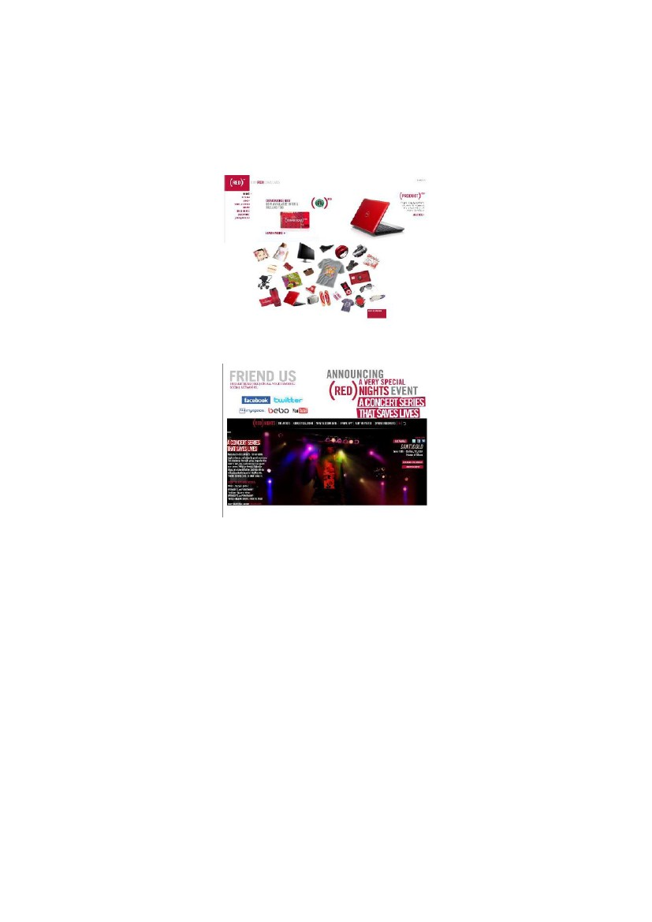
Nature Of Corporate Social Responsibility From The Point Of Marketing
Management View And Application Of Content Analysis On Social
Responsibility Projects
Figure 25. Fonterra’s Social Responsibility Projects
Source: http://www.fonterra.com/wps/wcm/connect/fonterracom/
fonterra.com/our+ business/sustainability/,2010.
The Case of Danone: Danone undertakes several social
responsibility projects in Bagladesh together with Muhammed Yunus who is
the founder of Grameen Bank and also famous for social responsibility
projects for the poor. Within the context of their projects, they found a little
dairy for producing nutrient and cheaper yogurt. Danone also designs water
purification projects for water beds in Cambodia aiming to supply healthy
water [38, 39].
The Case of the International Project-RED-: World’s leading firms
work in cooperation in a social responsibility project called as “RED”. The
aim of this project is to prevent the spread of HIV in Africa and also to
provide support for the treatment of the patients. This social responsibility
project provides funds for AIDS patients’ treatment and also for preventing
the spread of HIV.
Firms such as DELL, Apple, Starbucks, American Express, and
Converse produce products in red and donate the whole revenue generated
from the sale of these special red products to the project (See Figure 26).
RED also organizes several concerts to provide financial support for the
project (See Figure 27). It increases the attendence to the concerts by using
online community platforms such as Twitter and Facebook [40].
72
Serdar PİRTİNİ & Şakir ERDEM
Figure 26. RED’s special Red Products
Source: http://www.joinred.com/#shopred,2010
Figure 27. Concerts Organized by RED
Source: http://www.joinred.com/,2010.
4.
CONCLUSION
According to the norms of today’s global market, companies have no
luxury to underestimate the significant role of sustainable development
projects in creating an efficient organizational performance based on the
values and ethic of the society. Moreover, they should share the
accomplishment of these projects with the market on their official web sites
so that they would show how transperant they can be and open to public’s
and their sector’s evaluation on their performance. There is a great
73
Nature Of Corporate Social Responsibility From The Point Of Marketing
Management View And Application Of Content Analysis On Social
Responsibility Projects
opportunity for companies to customize the projects of social responsibility
to supply the needs of today’s consumers without destroying the sources
that the future generation would need. Even as seen in the study, the social
responsibility projects will be carried out with specialized units as a new
branch of marketing department as companies give more impact on social
responsibility actions. Hopefully this paper can be a source for a possible
quantitative research on the nature of corporate social responsibility
concerning the marketing management.
REFERENCES
[1] Clow, Kenneth E., Baack Donald (2004). Integrated Advertising, Promotion, and
Marketing Communications, Pearson Prentice Hall, New Jersey, p.413.
[2] Kerin, Roger A., Peterson Robert A. (2004). Strategic Marketing Problems Cases and
Comments, Tenth Edition, Pearson Prentice Hall, New Jersey, p.15.
[3] West, Douglas, Ford John, Ibrahim Essam (2006). Strategic Marketing Creating
Competitive Advantage, Oxford University Press Inc., New York, p.434.
[4] Sue Adkins (1999). Cause Related Marketing Who Cares Wins, Butterworth-
Heinemann, Oxford, p.6.
[5] Keinert Christina (2008). Corporate Social Responsibility as an International Strategy,
Physica-Verlag A Springer Company, Heidelberg, p.4.
[6] Marconi Joe, Cause Marketing : Build Your Image and Bottom Line Through Socially
Responsible Partnerships, Programs, and Events, Dearborn Trade Publishing, a Kaplan
Professional Company, p.2-8.
[7] Lynch Richard (2006). Corporate Strategy, Fourth Edition, Pearson Education Limited,
England, p.367.
[8] Haywood Roger, Corporate Reputation, The Brand and the Bottom Line : Powerful
Proven Communication Strategies for Maximizing Value, Kogan Page Limited, London,
p.221.
[9] Pirtini, Serdar, Tığlı Mehmet, Çelik Candan (2006). “The Effects of Cause –Related
Marketing Campaigns on Turkish Youth’s Consumption Behaviour and the Approach to
Cause –Related Marketing in the Turkish Industry”, Corporate Responsibility and Global
Business: Implications for Corporate and Marketing Strategy, THE ASPEN INSTITUTE
Business and Society Program, Conference hosted by London Business School, Poster
Session, 13-14 July 2006.
[10] Krippendorff, Klaus (2004). Content Analysis: An Introduction To Its Methodology,
Sage Publications. California, p.18.
[11] Weber, Robert P (1996). Basic Content Analysis, Sage Publications, California, p.9.
[12] http://www.eczacibasi.com.tr/articles/detail/detail2.asp?id=962&archive=1, 2010.
74
Serdar PİRTİNİ & Şakir ERDEM
[13] http://www.aygazayisigi.org, 2009.
[14] http://www.tetrapak.com/tr/about_tetra_pak/, 2009.
[15] http://www.cheetosgelisimmerkezi.com/, 2009.
[16] http://www.pg.com.tr/procter/surdurulebilirlik_sosyalsorumluluk.htm,2010.
[17] kardelenler.turkcell.com.tr, 2010.
[18] http://ortakalan.com.tr/haber.asp?S=292&HID=1379, 2009.
[19] www.gulumseyengelecek.com/, 2010.
[20] www.hayataarti.org/, 2010.
[21] www.kurumsalhaberler.com/wwfturkiye, 2010.
[22] www.koc.com.tr/tr-tr/Basin_Merkezi, 2009.
[23] http://www.efespilsen.com.tr/tiyatro.aspx, 2010.
[24] www.tumgazeteler.com/, 2009.
[25] http://www.vestel.com/index.aspx, 2009.
[26] www.calik.com/sayfa.aspx?id=8, 2010.
[27] copmadam.sabanciuniv.edu, 2010.
[28] www.sabancivakfi.org/tr/?programlar/hibe...gelisme, 2010.
[29] www.hurriyet.com.tr/magazin/anasayfa/10509308.asp,2010.
[30] www.bkmonline.net/tr/organizasyon.bkm,2010.
[31] www.saputo.com/consumers/social/,2010
[32] http://olympics.saputo.com/about.aspx,2010.
[33] http://www.arla.com/,2010.
[34] http://www.stonyfield.com/,2010.
[35] www.dairycrest.co.uk/, 2010.
[36] http://www.nestle.pk/community/corporate-social-responsibility.aspx,2010.
[37]http://www.fonterra.com/wps/wcm/connect/fonterracom/fonterra.com/our+business/sus
tainability/,2010.
[38] http://www.foodanddrinkeurope.com/Products-Marketing/Danone-takes-affordable-
nutrition-into-Bangladesh, 2010.
[39] http://www.1001fontaines.com/en/00_welcome/welcome.php,2010.
[40] http://www.joinred.com,2010.
75

